|  |  |
| --- | --- |
| **Assessment task – Narrogin Senior High School** | |
| Year level | 8 |
| Learning area | Technologies |
| Subject | Digital Citizenship |
| Title of task | Cyber Security |
|  | |
| Description of task | Students are to read a case study and analyse the information. From their analysis students will determine where there are security breaches within the company and the steps that can be taken to reduce the risk. |
| Type of assessment | Inquiry & Analysis |
| Assessment strategy | Network Diagrams |
| **Content description** | |
| Content from the Western Australian Curriculum | **Digital Implementation**  Implement and modify solutions, that include user interfaces within a programming environment, including the need for choice of options and/or repeating options (ACTDIP030)  **Digital Systems**  Methods of data transmission and security in wired, wireless and mobile networks (ACTDIK023) |
|  | |
| Assessment conditions | 4-5 Lessons in class |
| Resources | Computers |

**Check List**

* **Part A: Completed tables.**
* **Part B: Draft Paragraph in this booklet**
* **Part B: Good Copy Paragraph**
* **Part C: Presentation/Poster**

|  |  |
| --- | --- |
| **Marking key** | |
|  | Marks |
| **Inquiry Booklet (Part A)** | Marks |
| Part A – Table 1 (1 mark per box completed) | 8 |
| Part A – Table 2 (1 mark per box completed) | 5 |
| Part A – Table 3 (1 mark per box completed) – 2 companies chosen and discussed | 6 |
| Part B - Draft Paragraph is completed (boxes) | 1 |
| Part B - Draft Paragraph in full sentences is completed | 1 |
| **Subtotal** | **/21** |
| **Part B - Paragraph - Good Copy** | Marks |
| Paragraph accurately follows the PEEL structure, with coherent sentence structure and good spelling and grammar. It also references data from their survey | 5 |
| Paragraph mostly follows the PEEL structure, has mostly coherent sentences and mostly good spelling and grammar. Includes data that’s not referenced | 4 |
| Paragraph loosely follows the PEEL structure, has average coherent sentences and average spelling and grammar. Includes no data. | 3 |
| Paragraph makes minimal attempt at PEEL structure and follow spelling conventions. | 2 |
| Paragraph does not follow PEEL structure. No data. Poor spelling and Grammar | 1 |
| **Subtotal** | /5 |
| **Part C - Presentation** | Marks |
| Presentation is presented using a PowerPoint or digital poster and is visually engaging | /5 |
| Presentation includes detailed information on the physical assets owned by chatter (1 mark per physical asset that is identified) | /5 |
| Presentation includes detailed information on the potential cyber security threat posed by the physical asset (2 marks per threat) | /10 |
| Presentation includes detailed information on the informational assets owned by chatter (1 mark per physical asset that is identified) | /3 |
| Presentation includes detailed information on the potential cyber security threat posed by the informational asset (2 marks per threat) | /6 |
| Presentation includes detailed information about how other companies have been affected by cyber security attacks. (2 companies to be identified, 5 marks per company discussed) | /10 |
| Subtotal | **/39** |
| Total | **/65** |

**Task**

You have been tasked with looking into a cyber security breach at a company.

On the following pages is the overview, research, background information and articles of similar breaches in cyber security.

Using this information, you are required to complete a presentation or ‘pitch’ on the cyber risk that chatter faces and how they can improve their cyber security.

**What needs to be Completed:**

**Part A: Three tables on the following pages**

* Physical assets and potential cyber security threats
* Informational assets and potential cyber security threat
* How other companies have been affected by the cyber security threats. (For this table refer to the Articles provided, 2 companies need to be identified and discussed)

**Part B: Paragraph**

Using the PEEL structure, you need to write a PowerPoint outlining Chatter’s cyber risks, and which of the risks you think need to be addressed first and why.

**Part C: Presentation**

Using the information, you complete in the tables and the paragraph you need to present this information, as well as a background of the company using PowerPoint or a digital Poster.

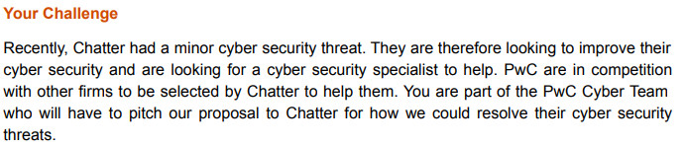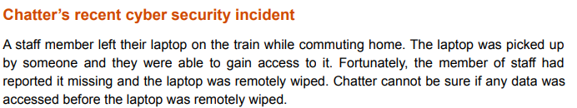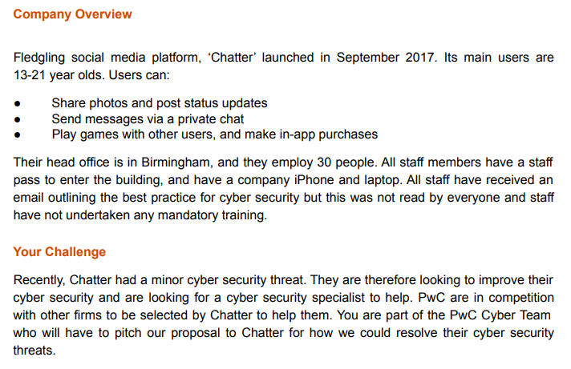**Overview**

**You as a member of PwC are to create a ‘pitch’ to be presented to the team at chatter (Part C).**

**This presentation needs to include:**

* Details on the physical assets of the company and the potential cyber security threats these pose (Table 1)
* Details on the informational assets of the company and the potential cyber security threats these pose (Table 2)
* Details on how 2 other companies have been affected by cyber security attacks and what chatter can learn from these (Table 3) *Refer to the news articles provided.*
* The cyber security risk faced by Chatter that they should try and address first. (Identified in either Table 1 or 2)
* A possible solution to the cyber security risk discussed.

**PART A –** Tables of Information

**Table 1 –**

|  |  |
| --- | --- |
| **Physical Assets** | **Potential Cyber Security Threats to Assess** |
| 1. Company iPhones for all staff members |  |
| 1. Staff and their awareness of cyber security (this is known as their cyber security culture) |  |
|  |  |
|  |  |
|  |  |

**Table 2 –**

|  |  |
| --- | --- |
| **Informational Assets** | **Potential Cyber Security Threats to Assess** |
| 1. Users must give their bank details when signing up to pay in-app games. |  |
|  |  |
|  |  |

**Table 3 -**

*How have 2 other companies been affected by cyber security attacks? What can Chatter learn from these experiences.*

|  |  |  |
| --- | --- | --- |
| **Company Name** | **Description of their cyber security attack** | **How might this be a risk for chatter?** |
| **1)** |  |  |
| **2)** |  |  |

**Task 2 – Part B – Paragraph**

You are required to write a PowerPoint explaining the choices that you made for your home network.

Use the draft paragraph below to help you create your paragraph. This can be in DOT Points. You will then write out your draft paragraph in full sentences on the following page.

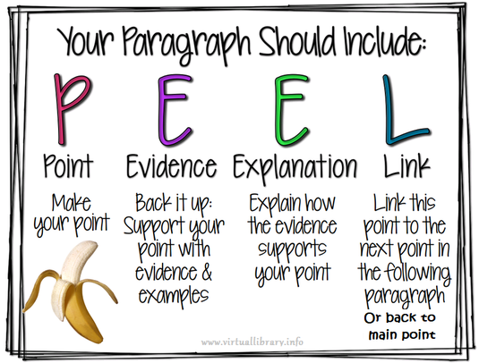Your good copy will need to be typed up.

**Draft Paragraph**

|  |  |
| --- | --- |
| **POINT**  What are you going to be communicating. |  |
| **EVIDENCE**  What equipment have you chosen to use. |  |
| **EXPLANATION**  Why have you chosen to use that equipment |  |
| **LINK**  Link your paragraph back to the main point. |  |

Turn the dot points above into a paragraph using full sentences below.

_____________________________________________________________________________________________________________________________________________________________________________________________________________________________________________________________________________________________________________________________________________________________________________________________________________________________________________________________________________________________________________________________________________________________________________________________________________________________________________________________________________________________________________________________________________________________________________________________________________________________________________________________________________________________________________________________________________________________________________________________________________________________________________________________________________________________________________________________________________________________________________________________________________________________________________________________________________________________________________________________________________________________________________________________________________________________________________________________________________________________________________________________________________________________________________________________________________________________________________________________________________________________________________________________________________________________________________________________________________________________________________________________________________________________________________________________________________________________________________________________________________________________________________________________________________________________________________________________________________________________________________________________________________________________________________________________________________________________________________________________________________________________________________________________________________________

